# CS 255 System Design Document Template

This template lays out all the different sections that you need to complete for Project Two. Each section has guidance to prompt your thinking. You will need to continually reference the interview transcript as you work to make sure that you are addressing your client’s needs. There is no required length for the final document. Instead the goal is to complete each section based on what your client’s needs are. Remove this note when you are finished, and replace all bracketed text with the relevant information.

## UML Diagrams

### UML Use Case Diagram

### UML Activity Diagrams

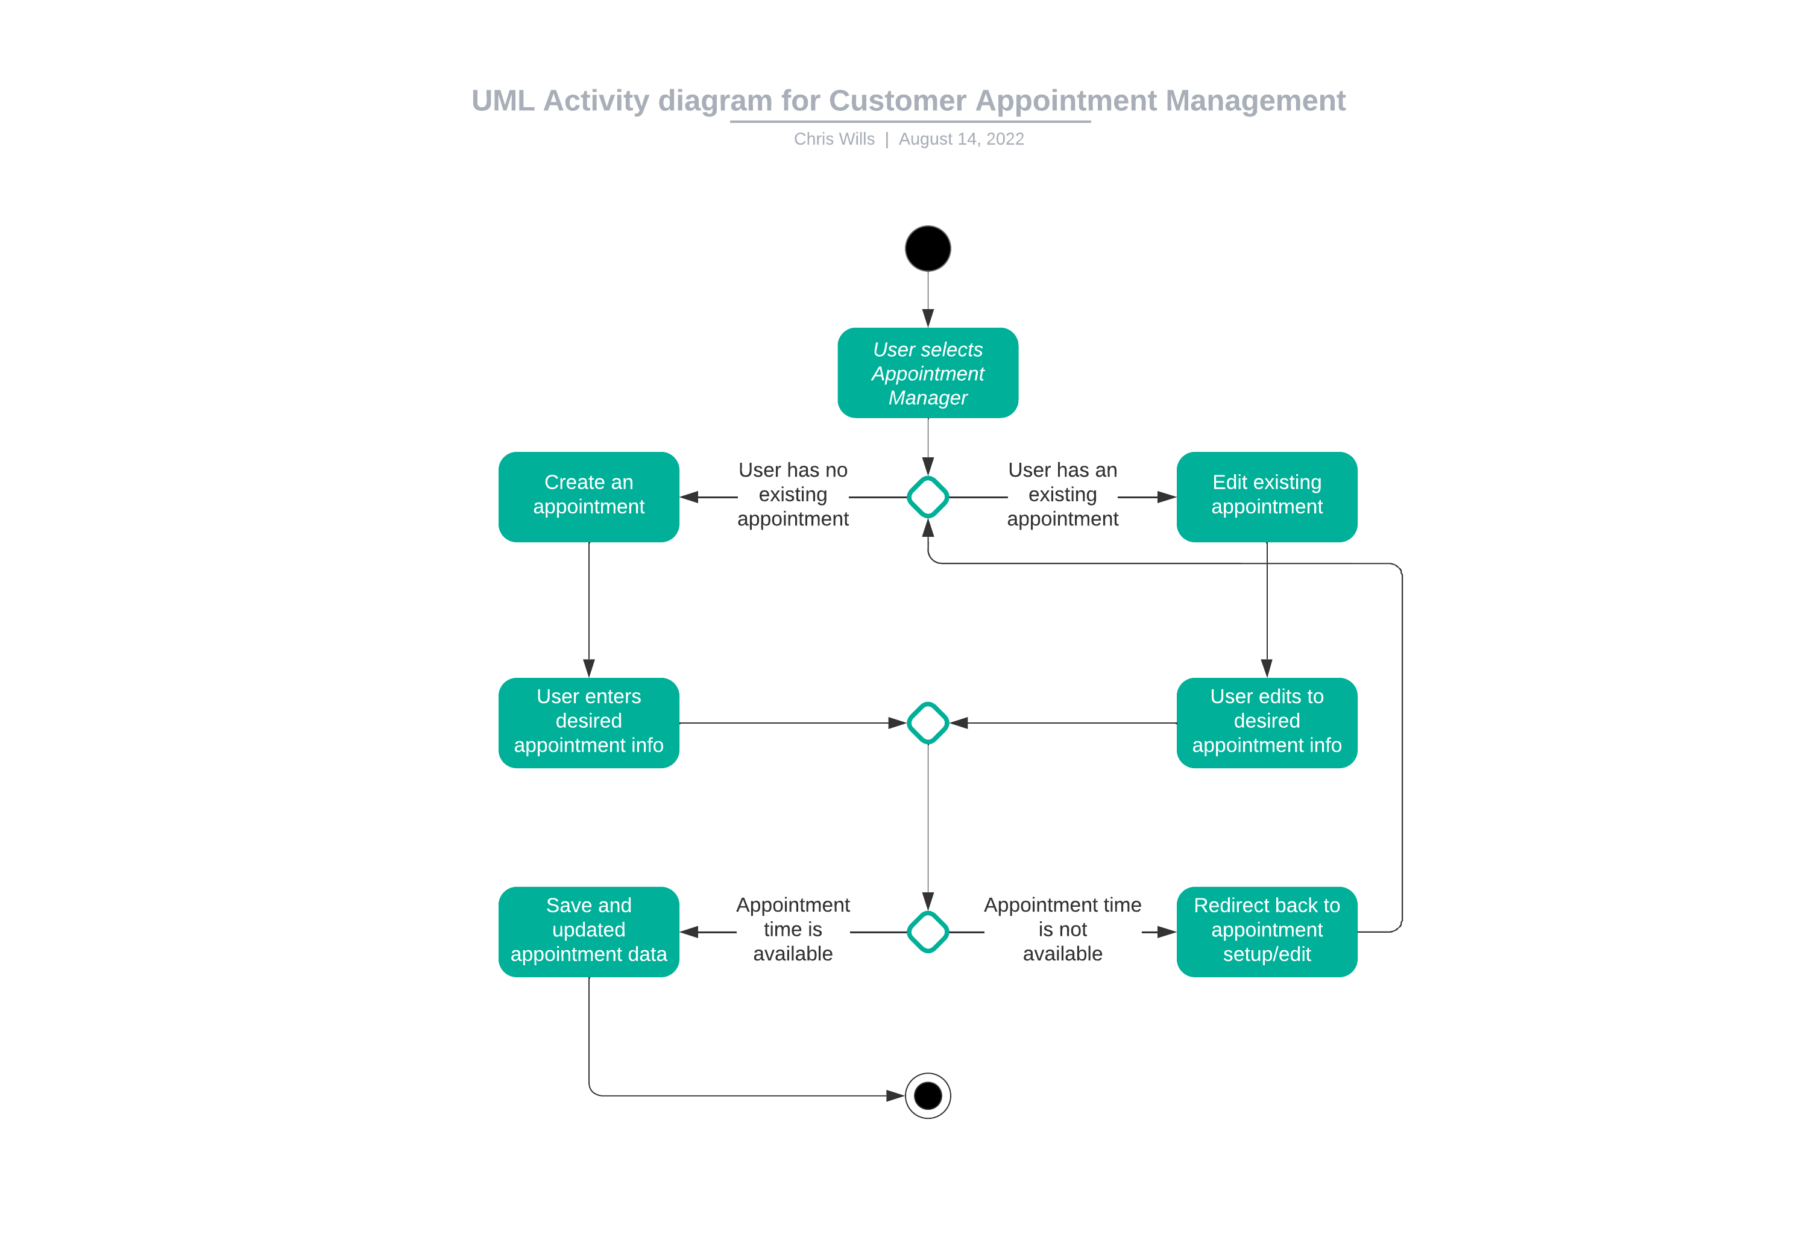

### UML Sequence Diagram

### UML Class Diagram

## Technical Requirements

Based on the diagrams above, several technical requirements exist. Concerning making appointments, currently DrivePass only exists within a certain geographical area. There is a limit to be implemented to ensure only local addresses can be used. The DriverPass system requires access to the internet, as well as a compatible device such as a PC or mobile phone. Going with a cloud operating system provides the most flexibility allowing for access anywhere, but we need to incorporate and verify proper security measures are in place, particularly for sensitive data such as passwords, addresses, and payment information.